Colchester Wheelchair Sports Festival a huge success
On Thursday 10 March, over 40 disabled people aged from 6 to 60 attended an all day wheelchair sports event at the Colchester Sports Park. The event was organised by WheelPower, the national charity for wheelchair sport and it provided everyone who took part the opportunity to try a variety of sports from Boccia to Table Tennis.
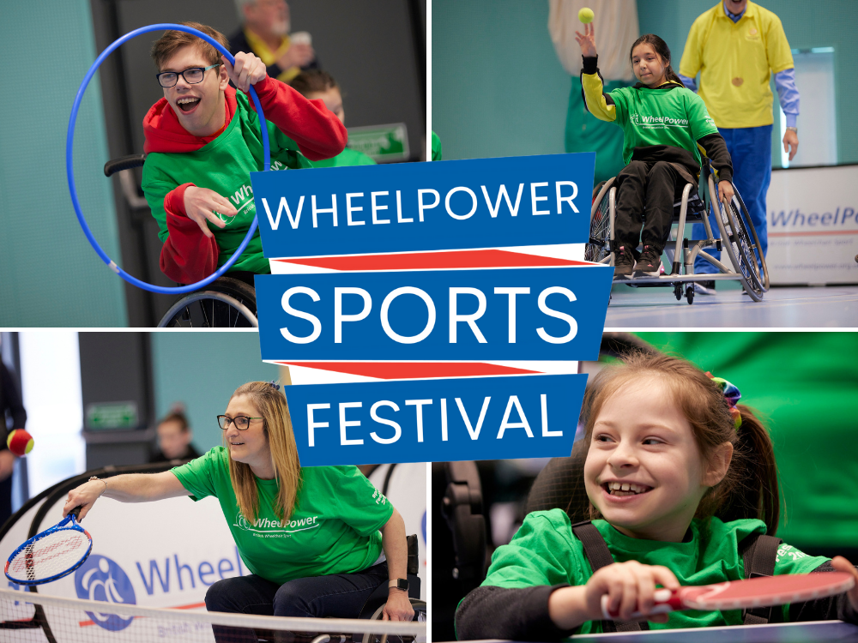
It was the first time WheelPower has hosted an event in Essex, and their first in-person event for over 2 years following the pandemic. The sports festival was supported by the Rotary Club of Colchester and by a number of local clubs, organisations and coaches who delivered a series of activities for the physically disabled children and adults who took part.
One of the young disabled people who attended the festival was 10 year old Dillon from Ipswich, who said “Playing sports makes me feel happy and it helps get rid of all the anxiety built up inside of me. The WheelPower Sports Festival has been great for trying new sports and finding out stuff you’ve never done before. I never knew I was good at table tennis before coming today and I really liked it. I’m going to find some sessions near me now.”
Trevor Sayer from the Rotary Club of Colchester told us, “We were delighted to finally bring the WheelPower Sports Festival to Colchester and it was a great success by all accounts. You see the participants arriving and lacking in confidence, not sure what the day will bring but once they start getting involved it all changes. They come away full of excitement, with improved self-confidence and really relish playing sport again. I am always a big promoter of sport for disabled people and opportunities like this are a fantastic enabler to ensure they have a great life, which is what they all deserve.”
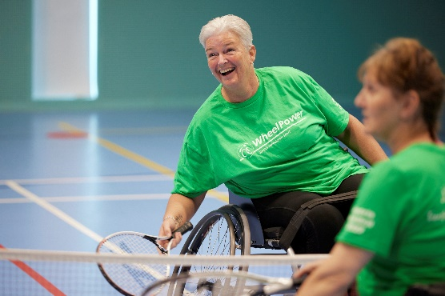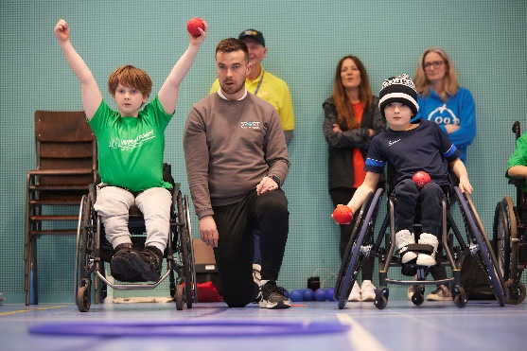
“The WheelPower Festivals are for many the first time trying a particular sport and it is our hope that these days inspire disabled people to lead healthier and more active lives when they return home. Sport has so many physical, social and wellbeing benefits and the smiles we saw in Colchester say it all. We are so thankful of support of the local community, clubs, coaches, families and volunteers from the Rotary Club of Colchester who all for contributed to a fantastic event in Essex.” Emily Weller, Head of Sport, WheelPower.
Note to Editors:
About WheelPower
WheelPower have been providing opportunities for people with physical impairments to take part in sport for nearly 70 years. Based in Stoke Mandeville Stadium, the Birthplace of the Paralympic movement, WheelPower is at the heart of wheelchair sport. From first-timers to Paralympic medallists, we support and promote participation at all levels. We have seen how playing sport can enrich lives, offering tremendous physical and psychological benefits, whatever your age or ability.
During the Covid-19 pandemic WheelPower continued to offer new opportunities for disabled people to get moving and stay active through a range of online events and digital resources. The Exercise at Home programme included the popular fitness videos, 3x weekly live online classes and the gifting of free exercise equipment. Together they have supported disabled people through a challenging time and will continue to be delivered alongside the charity’s flagship wheelchair sport events. In 2022 WheelPower is looking forward to a return of in-person events that include the Inter Spinal Unit Games, the National Junior Games and a series of regional Sports Festivals around the UK.
Website: www.wheelpower.org.uk
To find out more about the full calendar of upcoming WheelPower Events please visit https://www.wheelpower.org.uk/sport-events
Contact:
Matthew French, Marketing, Communication and Engagement Officer
Email: matthew.french@wheelpower.org.uk
Tel: 01296 395995

