Golfer’s Elbow/ Medial Epicondylitis

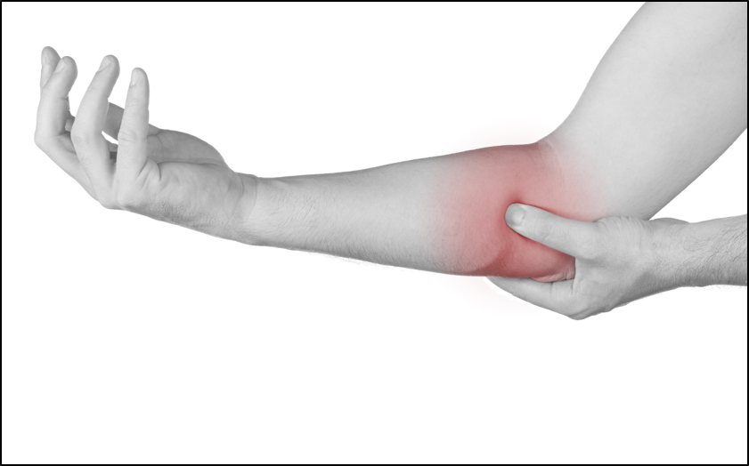

What is Golfer's Elbow?
Golfer’s elbow (medial epicondylitis) is a painful condition caused by overuse. Over time, the forearm muscles and tendons become damaged from repeating the same motions again and again. This leads to pain and tenderness around the elbow and may spread down your forearm.
This may cause:
- Pain with gripping, bending and twisting movements.
- Tightness in the forearm muscles.
- Tenderness when touching the area.

Prevent Golfer’s Elbow by following these steps:
- Stretching – engaging in a warm-up routine can improve flexibility, reduce stiffness and risk of injuries. Gentle warm up stretches help to activate and engage your muscles responsible for grip strength. This contributes to better control of the golf club and results in more consistent shots.
- Strengthening – Strengthening exercises can help balance muscle strength and reduce the strain on the tendons, this will lower the risk of developing golfer's elbow. These exercises can enhance the control over the golf club for precise ball striking and overall shots accuracy.
- Swing analysis – Work with a qualified golf instructor to ensure proper swing mechanics and technique. Improper swing mechanics can place excessive strain on the tendons and muscles of the elbow, leading to injury over time.
- Equipment – Ensure that golf equipment, including clubs and grips, are properly fitted and suited to your size, strength and swing style. Using poorly fitted equipment can contribute to improper swing mechanics and increase stress on the elbow.
- Rest and recover – Allow adequate time for rest and recovery between golf sessions to allow the muscles and tendons to repair and adapt to the demands of the sports. Avoid playing through pain or discomfort, as this can lead to damage and injuries.

Warm Up Stretches
- Hold for 30 seconds.
- Repeat 5- 10 times.

Wrist Stretch 1 Wrist Stretch 2 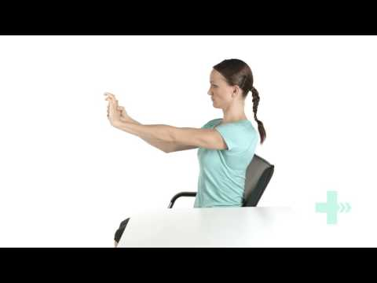

Full Body Warm Up Routine

Strengthening Exercises
- Repeat 10 times per sets.
- Do 2-3 sets a day.
- Take one minute break between sets.

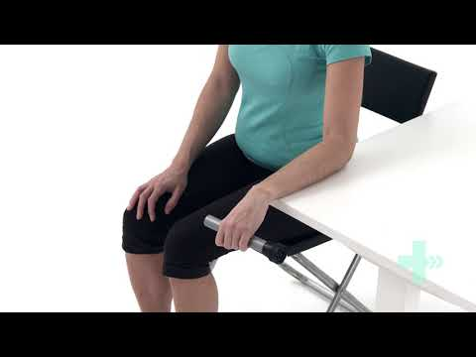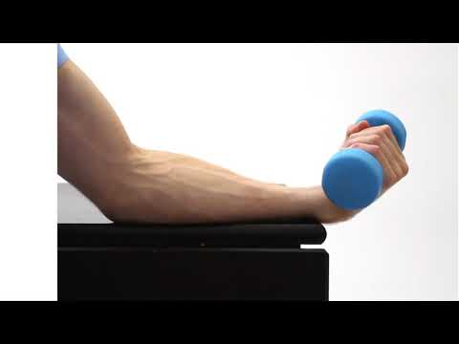

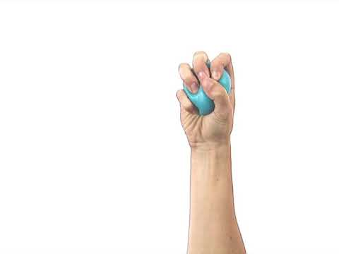

Equipment

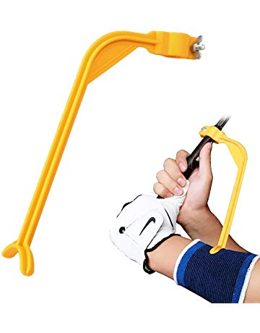
Swing Correction Tool can be used to help set the correct hinge position at the top of the back swing. It can be incorporated in training sessions to train and prevent certain movement patterns at the wrist that result in injury.
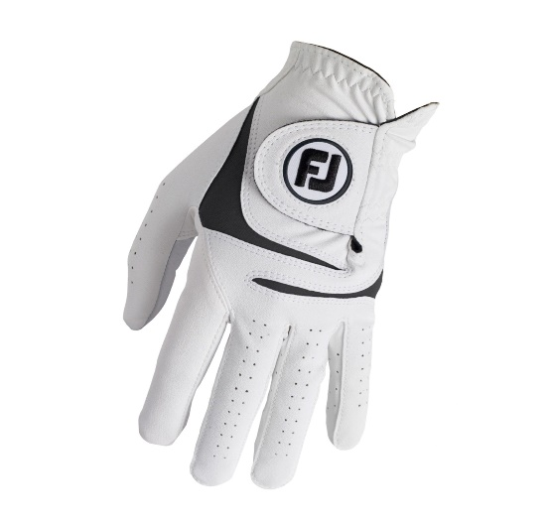

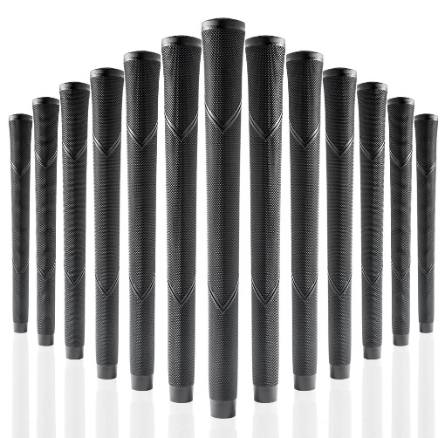
Golf gloves enhance grip, control, and comfort while swinging the golf club reducing strain on the wrist and elbow.

Larger golf grips reduce the amount of grip pressure needed during the swing, which can decrease strain on the tendons and muscles of the forearm and elbow.
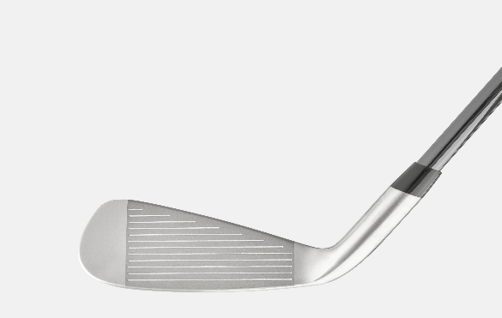

Lighter clubs require less effort to swing, resulting in reduced stress on the joints and muscles during the golf swing.

References

- Therapeutic Exercise Program for Epicondylitis - OrthoInfo - AAOS. (n.d.). Www.orthoinfo.org. https://orthoinfo.aaos.org/en/recovery/epicondylitis-therapeutic-exercise-program/.
- Golfer’s Elbow: Treatment and Prevention | HSS Sports Medicine. (n.d.). Hospital for Special Surgery. https://www.hss.edu/condition-list_golfers-elbow.asp.
- Golfers elbow. (n.d.). NHS Inform. Retrieved February 23, 2024, from https://www.nhsinform.scot/illnesses-and-conditions/muscle-bone-and-joints/conditions/golfers-elbow#Treatment%20of%20Golfer%E2%80%99S%20Elbow.
- Wrist Injuries in Golf. (2019, January 7). The Physio Lab. https://www.thephysiolab.com/news/2018/8/30/wrist-injuries-in-golf.
- Golfer’s Elbow (also known medial epicondylitis). (2023, February 8). Complete Physio. https://complete-physio.co.uk/golfers-elbow-also-known-medial-epicondylitis/.
- 01X Utility Iron. (n.d.). Caley. Retrieved February 23, 2024, from https://caleygolf.com/products/01x?variant=45725575905565&currency=GBP&utm_medium=product_sync&utm_source=google&utm_content=sag_organic&utm_campaign=sag_organic&gad_source=1&gclid=Cj0KCQiAoeGuBhCBARIsAGfKY7x6juKbPZXZNGKn9YLz9oKhtjTsLeCWpzLaWDP8o3JbCzmj4lH4XtYaAhxjEALw_wcB.

